Steel and Tube Holdings

Table of Contents

Introduction 3

The purpose 3

Company Overview 3

Discussion 3

Financial Performance 3

Value 4

Topical Issues 4

Conclusions & Recommendation 5

References 6

Appendices 7

Appendix A 7

Financial performance 7

Return on Equity 7

Appendix B 8

Holding Period Return 8

Share Price Performance 8

Appendix C – Finance Ratios 9

Market to Book Ratio 9

Brokers’ recommendation 9

### Introduction The purpose

As an investment analyst the purpose of the report is to aid the decision process of potential investors, by helping the potential investor decide where they should buy shares for Steel and Tubing Holding (STU)

### Company Overview

Steel & Tube was established in 1953 and became public in 1967. It is today one of New Zealand's leading steel solution suppliers, with access to the market's widest range of steel items via its statewide network of distribution. The company distributes and processes a wide range of steel products and operates via two divisions - Distribution and Infrastructure - to provide an end-to- end client experience, consulting, sourcing, and meeting clients' steel needs.

As a consequence of acquisitions of comparable businesses throughout the years, Steel & Tube currently has a portfolio of strong heritage brands. The organisation is dedicated to offering high- quality services and commodities to customers in a safe environment.

### Discussion

### Financial Performance

According to Appendix A, we can see that from the year 2017 to 2019 the revenue has stayed reasonably constant at the $500,000 for the 3 years, but in 2020 there was a significant drop in the in the revenue from the $500,000 to just above the $400,000 but in the years after 2020 the revenue has increased from $417,923 to 481,043 in 2021 and in 2022 the revenue is at its highest peak compared to the financial years before the revenue has reached a value of almost

$600,000 in revenue. The major drop in revenue in 2020 was due to the shortage of work due to the Covid-19 because the company could only supply essential business during the pandemic therefore was a short of work.

EBITDA (Earnings before Interest, Tax, Depreciation and Amorisation), the purpose of using EBITDA is to track and compare the companies underlying profitability regardless of their depreciation assumptions or financing choices. When we further examine the profitability graph on Appendix A we can see that the Revenue, EBITDA and Net income are correlated reason being when we look at the trend of all the variable the follow the same pattern reason being when revenue increases EBITDA increase, when EBITDA increased net income increase and vice versa.

Return of Equity (ROE) is a “ratio that provides investors with insight into how efficiently a company is handling the money that shareholders have contributed to it. ROE measures the profitability of a corporation in relations to stockholders’ equity” ("How to Calculate Return on Equity (ROE)", 2022). For STU the ROE for the current financial year is 14.37% this the highest ROE compared to the financial years 2017 – 2022, the lowest ROE was in the year 2020 with value of -33.10%.

### Share Price Performance

According to Appendix Steel and Tube Holding (STU) show the current list price as 14th September 2022 is 1.42(NZD). When we look at the current price of STU their similar current price in June 2018. There has been a massive drop in share for STU since early July 2017, this due the fact the “Steel and Tube Holding has faced multiple construction, infrastructure project challenges and delays, as well having intense competition on the marker leading to higher margins particularly in the construction sector" (Taylor, 2017).

The lowest point of the share price of STU was in March 2020 where the price dropped from 0.82 in February 2020 to 0.47 in March 2020, this since there was covid-19 outbreak in NZ which had a major effect on the all the industries including steel and tube. As per the prime minister’s instruction on 23rd March 2020 the company had to close all sites and where only.

allowed to supply essential business as of 25th March 2020. Due to the shut-down of the company there will be an adverse impact on the earnings for the year 30th June 2020 (NZX Company Research, 2020).

Furthermore, as a result of COVID-19 and the national lockdown restrictions on the economy and sector, STU was exposed to the anticipated significant impact on sales for the remainder of the fiscal year and beyond. When we examine the market price before COVID-19, we can see that sales were increasing as anticipated, and steel and tube have continued to be successful in gaining significant project contracts. We examine the market price for COVID-19 and how its lockdown has resulted in anticipated delays that have hurt sales in the second half of the fiscal year and left them significantly lower than the worst comparable period. (Steel& Tube Response to COVID-19, 2022)

Long-term redundancies, other execution, and network impairment expenses will be avoided as a result of the company's restructuring, which will also result in cost savings and increased efficiency. To combat COVID-19, the business implemented industry-leading practices to securely manage operations during alert level 3. The vast majority of Steel and Tube plants will be operational, and the business has put in place digital systems to enable customers with contactless product ordering and delivery. (Steel& Tube Response to COVID-19, 2022)

Geographical sales power of Steel and Tube Further rationalisation of the physical branch network is made possible by increased customer service capabilities, recent investments in digital capabilities, and customer e-commerce possibilities. There will be 150–200 layoffs as a result of these measures' effects on employment. (Steel& Tube Response to COVID-19, 2022)

### Value

The Price-to-Earnings ratio (P/E ratio) is used for valuing a company’s current share price relative to its earnings per share (EPS). For STU, the P/E ratio is 7.37. This is a good sign reason being that the market is confident that it will be profitable in the future reason being the investor is willing to pay 7.37 times the EPS of STU for the share price. This also means that having a low P/E ratio of 7.37 means that the share price is low, which is a good sign for investors.

The market to book ratio is a metric that compares your company’s book value to its market value, which is determined by its current price on the market and its total equity. For STU it can be seen that the Market to Book Value is 1.06 , having a Market to Book ratio of 1.06 which means that the market value is undervalued because its trading similar to it book value, in terms of investing the Market to Book ratio is good sign reason being it’s cheaper for the investor but having low Market to Book ratio means there is less growth to be predicted in the future which is bad sign for investor.

### Topical Issues

The system of direction and control used by corporations is known as corporate governance. The management of their companies is under the control of their boards of directors. The shareholders' role in governance consists of selecting the directors and auditors as well as ensuring that a suitable governance framework is in place.

Steel & Tube's corporate governance is based on high ethical and performance standards, and it is achieved through rigors governance rules, procedures, and processes that foster an open, transparent, and value-added culture for our stakeholders. Steel & Tube's governance structures and processes are reviewed on a regular basis by the Board of Directors in order to identify potential for improvement, guarantee consistency with best practices, and represent Steel & Tube's operations. The Board thinks that the Company's corporate governance structure conforms with the NZX Corporate Governance Code to a great extent.

### Conclusions & Recommendation

In the report above we clearly see that STU has struggled to maintain the market price when the market price dropped due to the global environment during the pandemic and the alert level 4 lockdown .Even though the market price has dropped during the pandemic the profitability of business has increase during the last 5 years specially in the year 2022.

When we examine the P/E ratio and M2B, we can clearly that is good sign reason being that the market is confident that it will be profitable in the future reason being the investor are willing to paying 7.37 times the EPS of STU for the share price.

However the M2B is relative low meaning that the market value is undervalued because its trading similar to it book value, in terms of investing the Market to Book ratio having low Market to Book ratio means there is less growth to be predicted in the future which is bad sign for investor.

My personal recommendation to any of the investor looking to buy shares of STU I highly suggest to you don’t buy and shares reason being the STU’s Market to Book reason is very low , therefore it predicted that there will be less growth in the future for Steel and Tube Holding

### References

NZX company research. (n.d.). *Steel and Tube FY2017 Earning Guidance.* Retrieved from NZX Company research: https://companyresearchnzxcom.ezproxy.aut.ac.nz/deep_ar/opennews.php?a=303744STU

NZX company research. (n.d.). STU Update on Covid 19. Retrieved from NZX Company research: https://companyresearch-nzx-com.ezproxy.aut.ac.nz/deep_ar/opennews.php?a=350564:STU

*How to Calculate Return on Equity (ROE)*. Investopedia. (2022). Retrieved 8 October 2022, from https://[www.investopedia.com/ask/answers/070914/how-do-you-calculate-return-equity-roe.asp.](http://www.investopedia.com/ask/answers/070914/how-do-you-calculate-return-equity-roe.asp)

What Is the Market to Book Ratio?. Gocardless.com. (2022). Retrieved 8 October 2022, from https://gocardless.com/en-us/guides/posts/what-is-market-to-book-ratio/.

NZX. 2022. Steel& Tube Response to COVID-19. [online] Available at:

<https:/[/www](http://www.nzx.com/announcements/352208).[nzx.com/announcements/352208>](http://www.nzx.com/announcements/352208) [Accessed 18 October 2022].

### Appendices

# Appendix A

### Financial performance

Profitability graph -STU

700,000

600,000

500,000

400,000

300,000

200,000

100,000

0

2017

2018

2019

2020

2021

2022

-100,000

Revenue EBITDA Net Income

## Return on Equity

**Steel and Tube Holding Ltd**

|  |  |  |  |  |  |  |
| --- | --- | --- | --- | --- | --- | --- |
| ROE | 9% | -19% | 4% | -33% | 8% | 14% |

(NZX company research, n.d.)

# Appendix B

**Holding Period Return**

Share Price 14th September 2022: $1.27 Share Price 14th September, 2017: $1.23 Return: (1.27 – 1.23)/1.23 = 3.25%

### Share Price Performance

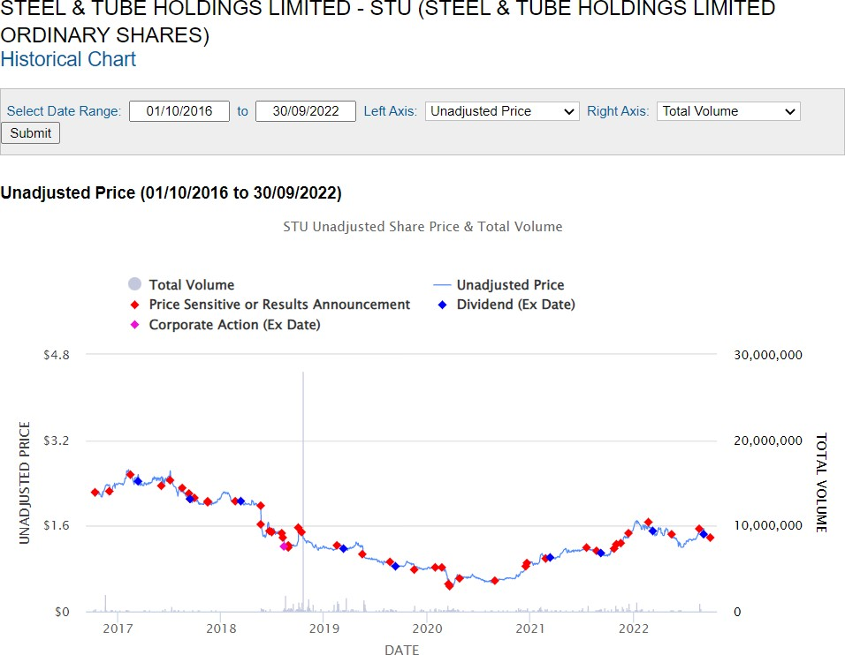

(NZX company research, n.d.)

# Appendix C – Finance Ratios

(NZX company research, n.d.)

## Market to Book Ratio

**Company Name:** Steel & Tube Holding

market price (date) 1.34

market capitalisation 222,436,704

total equity 210,101,000 market to book ratio 1.06

market price (date) 1.34

Profit 30,193,000

# Of shares 165,997,540 EPS 0.18

P/E ratio 7.37

(NZX company research, n.d.)

### Brokers’ recommendation

7th 0ct 2022

7th Oct 2022

